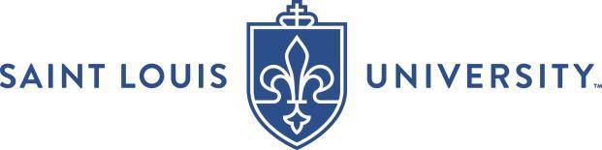

University Committee on Academic Rank and Tenure
Recommendation of the SLU Non-Departmental Colleague

Promotion and/or Tenure to be effective July 1, 2027

The Chair, Director, or Dean, as applicable, should complete the candidate information portion of this form and share it with the SLU Non-Departmental Colleagues reviewing the candidate.

The SLU Non-Departmental Colleague should prepare a recommendation letter addressing items a and b below, complete the bottom portion of this form, and submit it preceding their letter of recommendation to the Dean’s Office for inclusion in the dossier.

Candidate’s Name (First, MI, Last):
College/School/Library:
Department of Primary Appointment (if applicable):

Please review the Candidate Information Form before writing your recommendation. In your recommendation letter:

- Address specifically whether they have satisfied department/unit standards in (1) teaching, (2) research and scholarship, and (3) service. Include headings to distinguish material related to these three categories of evaluation.
- Clearly state your overall evaluation and recommendation.

 | Overall Evaluation and Recommendation: | ☐ Recommend ☐ Do Not Recommend
____________________________________ |  |  | Click or tap to enter a date.
Signature |  |  | Date

Printed/Typed Name:
Present Rank and Tenure:
Unit of Primary Appointment:

